Title: Day 9 – IoT Smart Home Dashboard (Deployment and Demonstration Phase)

Date: 27 Sept 2025
Name: Nihar Ashraf

Introduction:
The main goal of Day 9 was to deploy and demonstrate the fully developed IoT Smart Home Dashboard system.
This phase involved integrating all previously developed modules — Authentication, Device Control, Telemetry Logging, and Databases — into a single executable Java console application.
The objective was to ensure the system runs smoothly from start to end in a real environment and verify that all components communicate correctly between MySQL, DynamoDB, and the Device Simulator.

Activities Performed:
- Project Deployment Setup
- Verified that Java (JDK 23) and Apache Maven were properly configured in the environment variables.
- Built the project successfully using the commands:
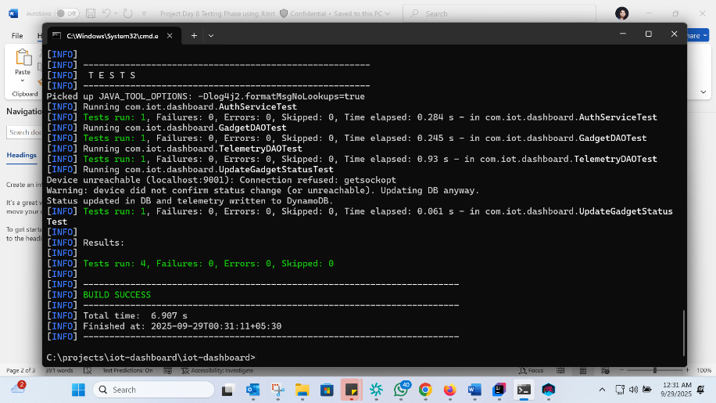
- Ensured that the IoT Dashboard runs from both IntelliJ and Windows Command Prompt.

- Database Validation
- Confirmed that the MySQL database has two main tables:
  - customers → stores registration details of each user.
  - gadgets → stores details of devices added by users (TV, Fan, AC, RoboVac, etc.).
- Verified that DynamoDB (Telemetry table) is running locally at http://localhost:8000 and is ready to store telemetry records such as device status updates (ON/OFF).

- Functional Demonstration (Live Execution)
Performed the following actions during the demo using the console-based Java application:
- Customer Registration: Registered a new user in the system and verified record creation in MySQL.
- Customer Login: Logged in successfully using valid credentials.
- Add Gadget: Added multiple devices (TV, Fan, AC, RoboVac) to the customer’s account.
- Change Gadget Status: Switched devices ON and OFF, which triggered telemetry updates in DynamoDB.
- Remove Gadget: Verified that the gadget removal operation correctly deleted the record from MySQL.
- Error Handling: Tested cases like unreachable device, invalid login, and ownership mismatch — all handled gracefully by the console system.

- Network Topology Visualization
- Created a Star Topology Diagram using PlantUML to visually represent the system’s connectivity:
      - Multiple clients (users) connect to the IoT Dashboard App.
      - The dashboard communicates with devices (TV, AC, Fan, RoboVac).
      - Device status updates are stored in SQL Database (gadgets) and Telemetry DB (DynamoDB).
    - This diagram helps to demonstrate how data flows from user → device → database in real time.

- Testing During Deployment
- Ran the final integration test by performing end-to-end operations.
- Verified that telemetry updates were properly logged in DynamoDB with correct timestamps.
- Observed that MySQL and DynamoDB remained synchronized throughout the test.
Results and Observations:
- The IoT Smart Home Dashboard executed successfully in both IntelliJ and Command Prompt.
- All modules worked together seamlessly — registration, login, gadget control, telemetry logging, and removal.
- The system handled invalid inputs and network issues without crashing.
- The DynamoDB telemetry records displayed accurate timestamps and device activity logs.
- The final topology visualization clearly represents real-world IoT communication.

Learnings:
- Gained hands-on experience in deploying a Java-based IoT system using Maven and local databases.
- Understood how to simulate and demonstrate IoT networks in real time.
- Learned the practical process of validating an application in a real runtime environment.
- Improved debugging and integration testing skills during the demonstration phase.

Conclusion:
Day 9 focused on the deployment, validation, and demonstration of the IoT Smart Home Dashboard.
All system components — MySQL, DynamoDB, and the Java console application — were successfully integrated and tested in a real execution environment.
The project is now completely functional, tested, and ready for Day 10: Final Presentation and Documentation Submission.

